Your contact person:

Oliver Kunzweiler
Head of Central Marketing

Telephone +49 9341 86-2169
Oliver.Kunzweiler@weinig.com

2 June 2023

Word count: 95
Characters (incl. blank spaces): 684

Date

PRESS RELEASE

Personnel news
Weinig Vertrieb und Service GmbH & Co. KG

Weinig Vertrieb und Service GmbH & Co. KG
expands its Corporate Management

Mr. Michael Bock has been appointed as a further Managing Director of
Weinig Vertrieb und Service GmbH & Co. KG (WVSG) with effect from 1 April 2023.
He now represents the company together with Gregor Baumbusch, who, in addition to his role as CEO, is also responsible for WVSG’s sales division. Michael Bock is responsible for the project business and also heads the Weinig System Solutions division.
Michael Bock was previously successful in management positions at international systems engineering companies and took over the management of the Weinig System Solutions division at WVSG in August 2022.
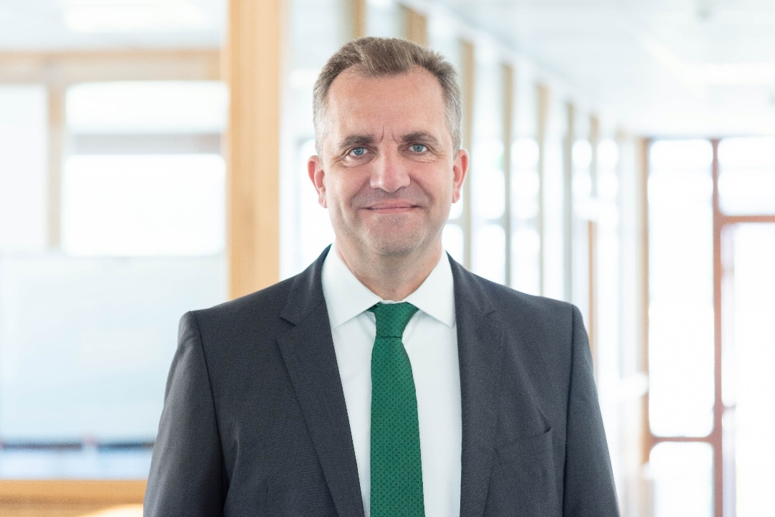

Michael Bock | Photo: © Weinig Vertrieb und Service GmbH & Co. KG

